Submit Turn-Ins (For Students)
Hillary L.
Last Updated: August 28, 2015 20:22
This topic covers how to submit a turn-in assignment.
- First, select the class for which you would like to submit a turn-in.
- Select Turn-ins on the left sidebar.
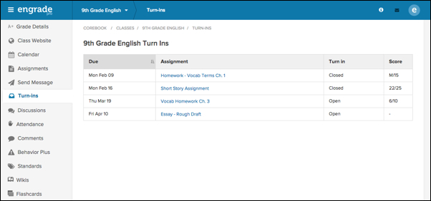
- Select the name of the turn-in you wish to submit.
If the status of the turn-in is Closed, or your teacher has already assigned a score to a turn-in, you will not be able to submit the assignment.
- To submit a file with your turn-in, select the File icon.
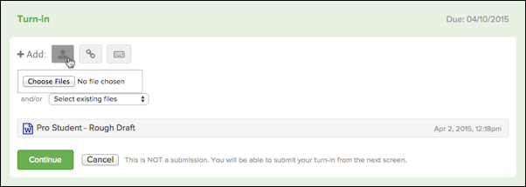
- Click the Choose Files button to select a file from your computer to upload, or you can select an existing file from the drop-down menu.
- To submit a link with your turn-in, select the Link icon.
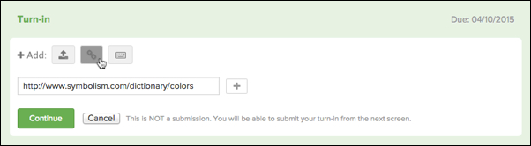
- Enter the link's text into the empty field.
- To add multiple links, click the + icon. An additional field will display in which you can enter another link.
- To add text, images, or videos to your turn-in, select the Text/Multimedia Entry icon.
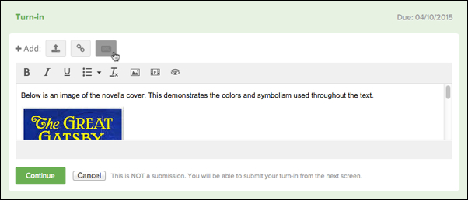
- You can enter text directly into the text editor, and use the options available on the formatting bar to format the text.
- To insert an image, select the Insert/edit image icon from the formatting menu.
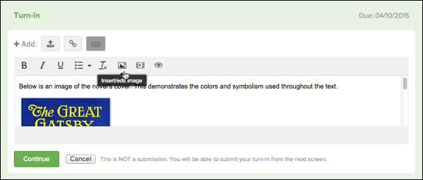
- To insert a video, select the Insert/edit video icon from the formatting menu.
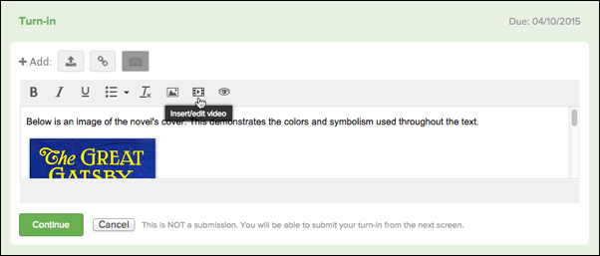
- To preview how your entry will appear for your teacher, select the Preview icon.
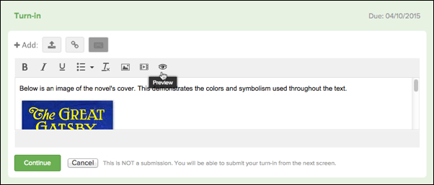
- Once you have added all materials for your turn-in, click the green Continue button.
You can add up to 10 items total with your submission.
- Under Turn-In Discussion, you can leave a comment for your teacher, if desired.
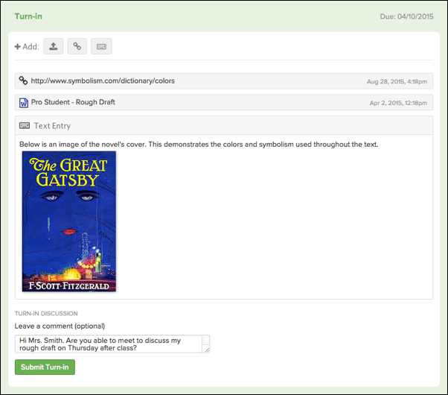
- Click the green Submit Turn-in button to submit your turn-in.

