Grade Turned In Assignments
Hillary L.
Last Updated: September 15, 2015 09:42
This topic covers how to view and grade turned-in assignments.
- Select a class to view turn-ins for that class.
- Select Turn-ins from the left sidebar.
- On the Turn-ins page, you can view all of the assignments in your class that have Turn-Ins enabled. You can click Assignment, Due, or Status to sort the assignments on the page.
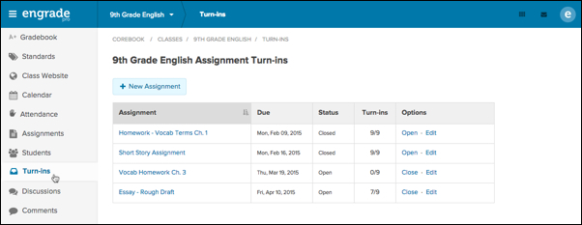
- The status for an assignment will either be Open or Closed.
  - Open indicates that an assignment has turn-ins enabled and the due date for turning in the assignment has not passed.
  - Closed indicates that students can no longer submit turn-ins for that assignment.
- You will be able to see how many students in your class have turned in the assignment under the Turn-ins column.
- To view turned in assignments, click on the name of an assignment.
- Select View to the right of a student’s name to view their turn-in.
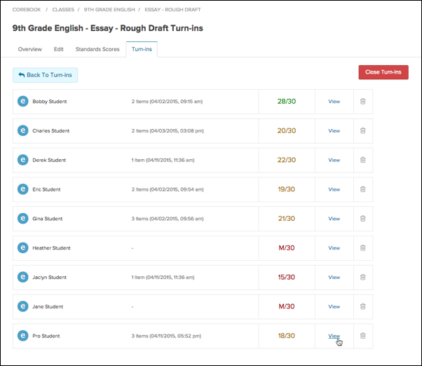
- If the selected student included a file with their turn-in submission, the file will display in a file viewer.
  - To download the file to your computer, hover over the file and select the pop-out icon at the top right corner. The file will open in a new browser tab or window.
  - Select the Open original icon at the top of the screen to download the file to your computer.
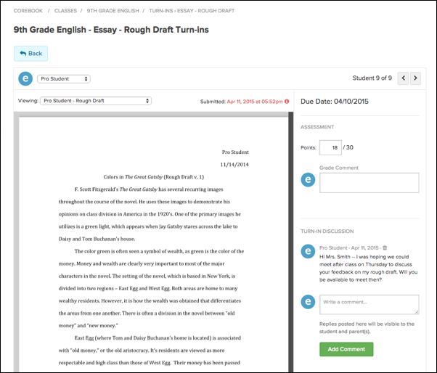
- Back on the Turn-Ins page, you can view additional files or items submitted by the same student.
- Click the drop-down menu next to Viewing: and select another file or type of content you wish to view.
  - Select Submitted Links to view any links submitted by the student.
  - Select Text and/or Multimedia Entry to view any text or multimedia submissions, such as images or videos.
  - Any additional files submitted by the student will also be listed in this menu.
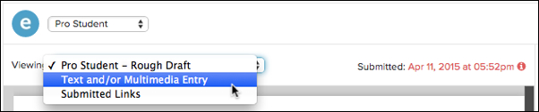
- Once you have reviewed a student’s entire submission, you can enter their score in the field next to Points:
Once you assign a score, the student will no longer be able to submit any additional items for that turn-in, even if the turn-in has not been closed. However, if you assign an M to denote a missing assignment, the student will still be able to provide a submission.
- You can enter any comments for the student in the field under Grade Comment.
- To create a private discussion between yourself and the student regarding their turn-in, you can type your comments in the available field under Turn-In Discussion. Select the green Add Comment button to initiate a discussion.
  - Any comments the student types back to you in response will be visible on this page.
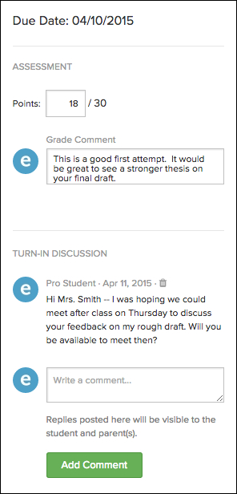
- To view turn-ins submitted by other students in your class, you can navigate through your student list using the arrow buttons at the top right. Alternatively, you can select a student’s name from the drop-down menu at the top left to navigate directly to that student’s turn-in.
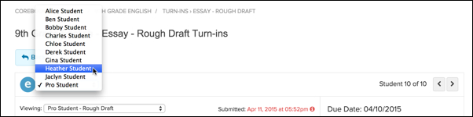
- To go back to the student list view, select the Back button at the top left.
- If the due date for the assignment has passed, or you wish to disable student submissions for the turn-in, you can select the red Close Turn-ins button at the top right.
