Create Turn-Ins
Hillary L.
Last Updated: July 24, 2015 13:50
This topic covers how to create a turn-in assignment.
- Select a class.
- Select Turn-ins from the left sidebar.
- On the Turn-Ins page, you can view all of the assignments in your class that have Turn Ins enabled.
  - Click the Open link in the Options column to the right of an assignment to enable student submissions for that assignment.
  - You can click the Close link to the right of an assignment to disable student submissions for that assignment.
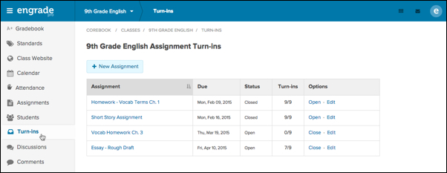
- Select the New Assignment button at the top left to create a new turn-in assignment.
- Enter the details for your new assignment, including Name, Due Date, Points Possible and Category.
- Select More options… to reveal additional settings.
- Check the box next to Add this assignment to class Turn-ins to enable turn-ins for the assignment.
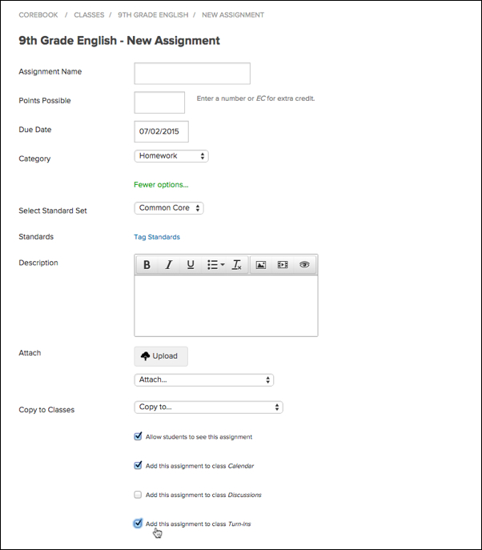
- Select any additional options as desired.
- Select the green Save Assignment button to create your turn-in.
- To enable turn-ins for an existing assignment, select Gradebook on your left sidebar.
- Select an assignment from your Gradebook.
- Check the box next to Add this assignment to class Turn-ins.
- Select the green Save Assignment button to save your changes.

