Create Flashcards
- Hover over Apps on the top blue bar and select Flashcards from the drop-down menu.
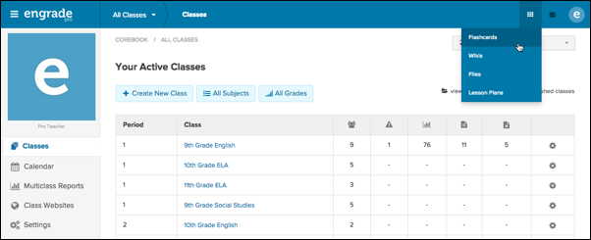
- Select the Create New Flashcards button at the top left.
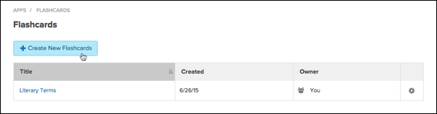
- On the Create New Flashcards page, enter the basic information for your flashcard set, including: Title, Description, Grade Level, and Subject.
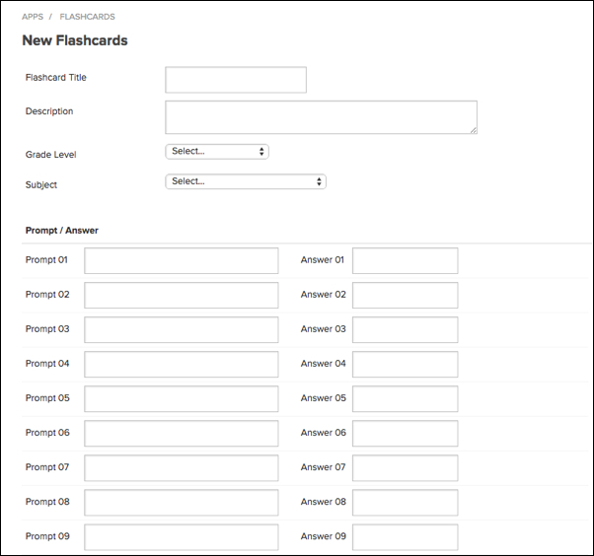
- Under the Prompt / Answer section, enter your prompts (questions/terms) and the corresponding answers. You can add up to 50 flashcards per set.
- Click the green Submit button to create your flashcard set.

