ADD ACTIVITIES TO LESSON GRID
The Lessons grid allows you to organize the materials you plan to teach onto an easy-to-use weekly calendar grid. In addition to the content you have created, you may have access to third-party content, if provided by your district. Once you have determined which materials you would like to use in your class, you can easily assign content to your entire class or to custom groups of students. This article describes how to assign activities to your class.
- First, select a class to access the Lessons page.
- Select Lessons on the left sidebar.
- Select the Add Activities tile to the right of a date to add content to the selected date.
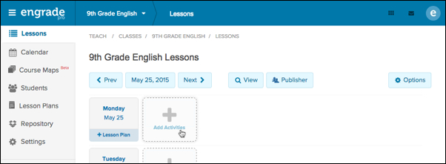
- You can assign activities to your entire class, or a custom group of students. For detailed instructions on how to create student groups, please see the support article: Create Student Groups
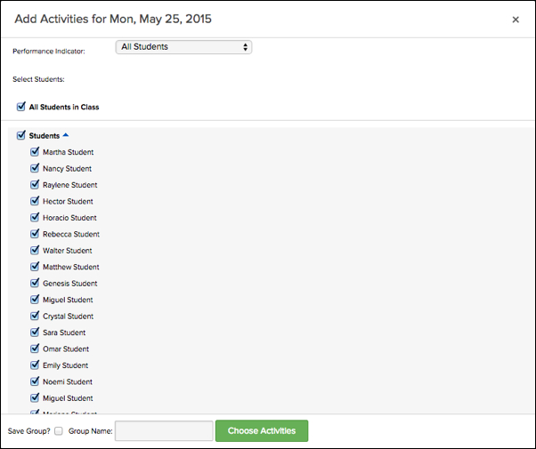
- Once you have finished selecting students, click the green Choose Activities button to proceed to the next screen.
- At the top of the Add Activities window, you can select a standards set to filter available materials by standard. In the pop-up window, you can select the standard(s) you wish to filter by, and select the green Submit button to view materials that are tagged with the selected standards.
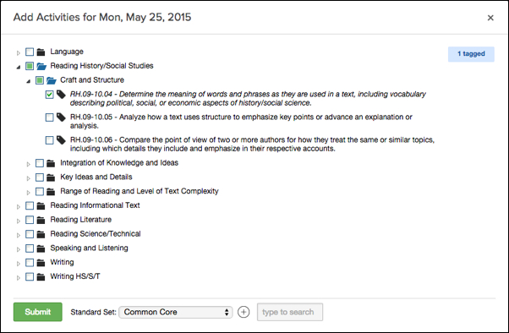
- Select the type of resource you would like to assign to your class.
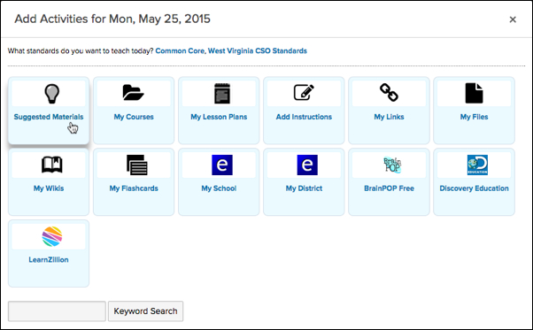
- Select My Courses to view course map folders that are aligned with your class’s subject area and grade level will be listed. Select a course map to add materials from the folder to the Lessons grid for your class.
- Select Add Instructions to type instructions or a message to your students for the selected date.
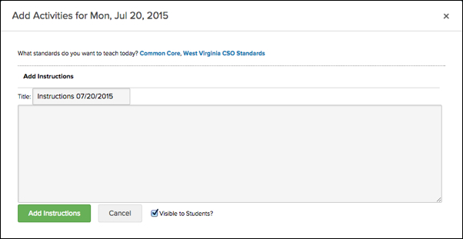
- Select My Links to assign a link to your class.
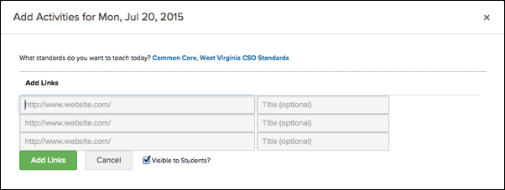
- Select My Files to assign a file to your class.
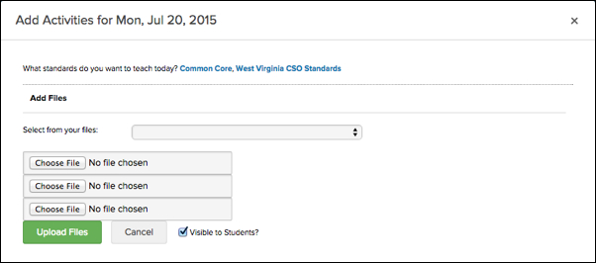
- Select My Wikis to assign a wiki to your class.
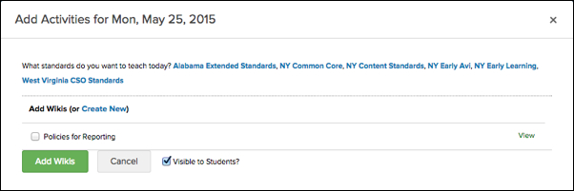
- Select My Flashcards to assign a flashcard set to your class.
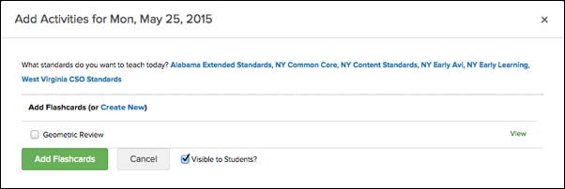
- Select My Tests to assign a test from your test library to your class.
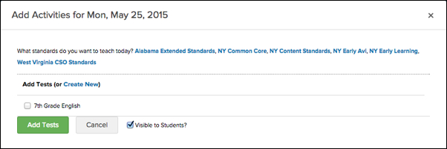
- Select Add Assignment to create and assign a new assignment.
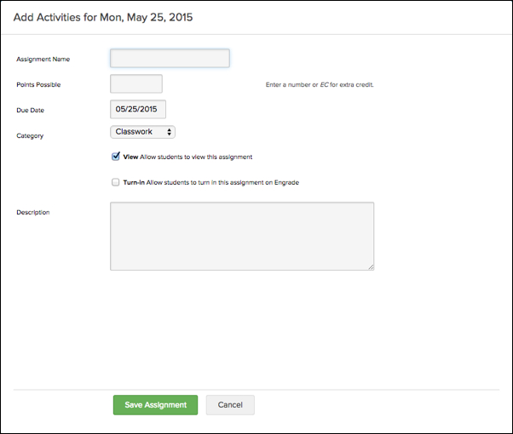
- Select My School to browse and select various items that have been shared with your school and approved by an administrator.
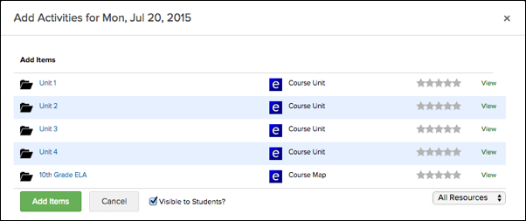
- Select My District (if applicable) to browse and select various items that have been shared with your district and approved by an administrator.
- If you wish to assign content from a third party provider, select a provider to browse their available content.


